Website Map

Sitemap UML Diagram
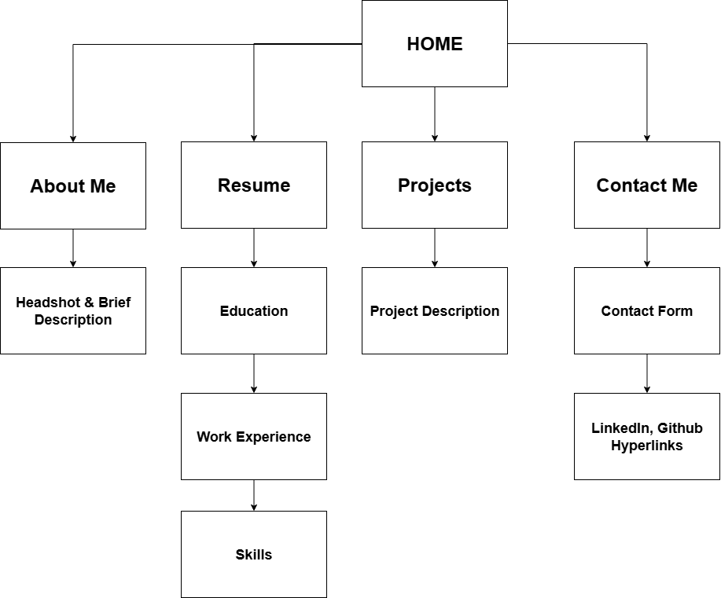

Page Descriptions
Home
Serves as the landing page with a professional headshot, a short introduction, and navigation to the rest of the site.
About Me
Provides background information including academic history, career interests, and personal motivations.
Resume
Organized into subpages for education, work experience, and technical skills. Offers recruiters a structured digital resume view.
Education
Highlights university, coursework, and achievements.
Experience
Lists professional and technical roles with responsibilities and accomplishments.
Skills
Showcases programming languages, tools, and certifications with icons.
Projects
Showcases major academic or personal projects with short descriptions, technologies used, and links to GitHub repositories or demos.
Project Description
Each project section describes one project with visuals, summary, and outcomes. Also includes skills represented through logos/icons of programming languages.
Contact
Provides ways to connect via a form, email link, or external links to LinkedIn, GitHub, or other professional platforms.

